**Are you wanting to play a sport in college?**

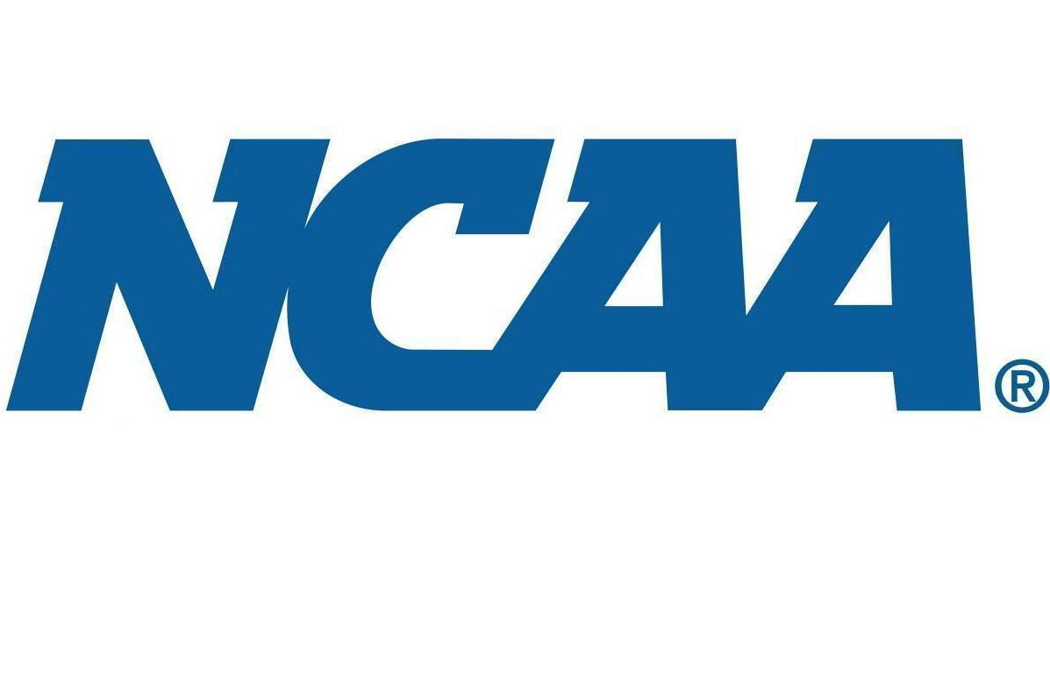 **at Lawrence Free State High School**

**____________________________________**

If you plan to be NCAA eligible and play D1 or D2 athletics, it is your responsibility to set up an account with NCAA the beginning of your sophomore year and check to see what Free State classes are NCAA approved

**Here are some things that your counselors CAN help you with in regards to NCAA eligibility requirements:**

* Tell you which Free State classes are approved or not approved by the NCAA
* Give you a worksheet to help you determine what classes you need to enroll for
* Help submit fee waivers (when eligible)
* Encourage you to create a NCAA account at eligibilitycenter.org

**Here are some things that your counselors CANNOT do:**

* Tell you which classes from another school are approved or not approved by the NCAA
* Take responsibility for making sure you selected the correct classes to be NCAA eligible.

**Here are some things that are the STUDENT’s responsibility:**

* Create a NCAA account at eligibilitycenter.org
* Maintain your GPA according to NCAA standards
* Keep track of the classes you need to become NCAA eligible
* Choose the correct classes

**The Free State Athletics website is your one stop shop for information pertinent to those student-athletes who want to compete at the collegiate level.  Please visit the website by going to**[**www.freestateathletics.com**](http://www.freestateathletics.com/)**, select the "More" tab in the green ribbon, and then select from the list provided under "College-Bound Student-Athletes."**

**To calculate your NCAA core-approved courses GPA, see:**

[**https://www.ncaa.org/student-athletes/future/grade-point-average**](https://www.ncaa.org/student-athletes/future/grade-point-average)